Project Identification

Project: | Inventory Management System
Prepared By: | Rajat Rajat, Gourav Gourav, Muskan Batra, Nirav Sorathia
Document Version: | 1
Published Date: | September 27,2019

Contributors

Name | Title
Rajat Rajat | Student
Gourav Gourav | Student
Nirav Sorathia | Student
Muskan Batra | Student

Distribution

Name | Title
Rajat Rajat | Student
Gourav Gourav | Student
Nirav Sorathia | Student
Muskan Batra | Student

Referenced Documents

Version number | Title | Author | Date | Source / Location
I | “Inventory Management and Production Planning and Scheduling” | Moon, Ilk young | 2001 | Interfaces (31.6), Pg.-125-127
|| | Web Integrated Decision Support System for Machine Scheduling and Inventory Management | Krishna, L Sivarama; Janardhan, G Ranga; Rao | 2009 | IUP Journal of Operations Management (8.1), Pg.- 35-52
III | Study of vendor-managed inventory practices in Indian industries | Borade, Atul B; Bansod, Satish V. (2010), | 2010 | Journal of Manufacturing Technology Management (21.8), Pg.- 1013-1038.

Revision History

Version Number | Revision Date | Summary of Changes | Modified by
| | 09/05/2019 | Recruitment of project summary | Nirav Sorathia
|| | 09/12/2019 | Creating more features for the project | Rajat Rajat
||| | 09/19/2019 | Modifying the summary with new features | Gourav Gourav
|V | 09/26/2019 | Finalizing the changes made | Muskan Batra

TABLE OF CONTENTS
1. Business Context Diagram 3
2. REquirements Scope Statements 4
3. High Level Business Requirements (HLR) Traceability 4
4. High Level Business Requirements Sign-Off 5

- Business Context Diagram
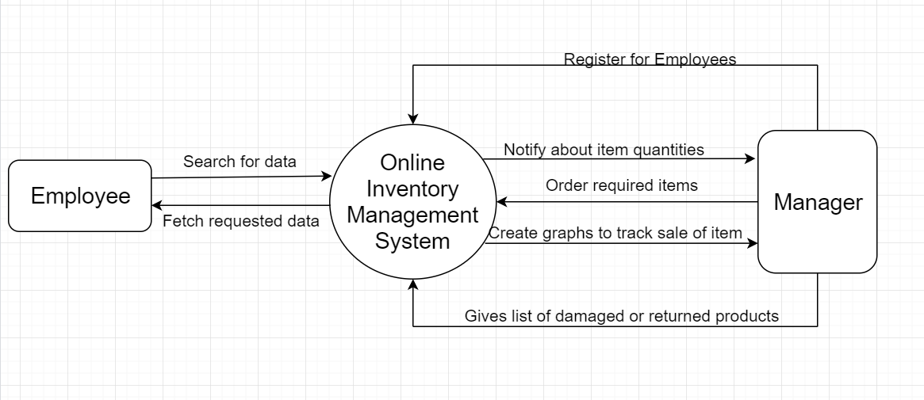

Requirement Scope Area | Description
Track Inventory | It is the responsibility of inventory manager to make sure that the organization has right amount of stock to meet the demands of consumers.
Formulation of policy | The policies of investment procurement, storage, handling, accounting, storage and stock outs, etc. are to be formulated under the scientific system of inventory control.
Effectiveness towards running of store | The determination of policies of the location, layout and materials and storage handling equipment certainly help in the effective working of stores organization.

External Entity | Description
Manager | Higher level user who will make use of complete application to enhance his/her inventory system
Employee | Lower level user who has limited access to the application

Information Flows | Description
Search for data | Employee can search for item to check whether item is available or not in inventory
Fetch requested data | Application will give available number of counts of item as result
Register for Employees | Manager will sign up for new employee and provides username and password for future use of application
Notify about item quantity | Web Application will notify manager when quantity of item is less than certain amount
Order required items | Manager can re-order items before it goes out of stock through web application
Gives list of damaged or returned products | Web application will generate a separate list for damaged and returned list of items so that manager does not have to worry about it.
- Requirements Scope Statements
HLR# | Description | Priority  (H, M, L)
 | Manager must be able to Login to system | H
 | Manager must be able to do register for employee | H
 | Employee must be able to Login to system | H
HLR04 | Manager must be able to add new items to the system | H
HLR05 | Manager must be able to see list of damaged or returned item | M
HLR06 | Manager must be able to see the graph of sales | L
HLR07 | Employee must be able to check available items of quantity | H
HLR08 | Manager must be able to reorder items | M
HLR09 | Manager must be notify by system if number of item goes less than certain amount | L

- High Level Business Requirements Sign-Off
The undersigned acknowledge their agreement with the contents of Version .9 of the High-Level Requirements document for Inventory Management System.

Following approval of this document, requirements changes will be governed by the project’s change management process, including impact analysis and appropriate reviews and approvals, under the general control of the Project Plan and according to company policy. Approved Change Request Documents, if present, will be attached to this Requirements Document as updates.

Name | Project Role and  Functional Area | Date Signed
Nirav | Role: Project Manager  Overall analysis of project and back end coding
Muskan | Role: Front End Developer  Creates the flow of working and front end designing
Rajat | Role: Programmer  Error handling, decoding and logic development
Gourav | Role: Delivery Manager  Full stack development and back end coding

* Note: physical signatures are not required. Email approvals are acceptable and should be appended to project documents.

